**Invitation for March NZISF seminar**

Date/time/format: Thursday, 13th of March, 0800h, Auckland time, on ZOOM

[](https://events.humanitix.com/nzisf-mar-2025)

[**https://events.humanitix.com/nzisf-mar-2025**](https://events.humanitix.com/nzisf-mar-2025)

**Seminar topic: AI and Software Code – Some Legal Issues**

The seminar explores the legal issues surrounding the use of Artificial Intelligence (AI) in software code creation. ​

The presentation begins by discussing general principles of liability for faulty software, including contractual, product, and tort liability, as well as consumer protection laws.

​It then examines how software creators can limit their liability through contractual provisions, quality assurance, and compliance with standards. ​

The role of AI, particularly large language models (LLMs), in generating code is analyzed, highlighting the complexities of authorship, copyright, and liability. ​

The seminar also addresses the legal implications of AI-generated content, including defamation and data privacy concerns and compares the regulatory approaches of New Zealand, which relies on existing frameworks, and the European Union, which has enacted comprehensive AI-specific legislation.

​ The conclusion emphasizes the need for understanding AI's workings to inform legal outcomes and suggests that existing legal principles can be adapted to address the challenges posed by AI in software development.

It is argued that while fundamental legal principles remain applicable, the involvement of AI introduces new complexities that require both legal adaptation and regulatory clarity. Given AI’s rapid evolution, legal responses are likely to remain dynamic, balancing innovation with consumer protection and liability considerations.

**Presenter: David Harvey**

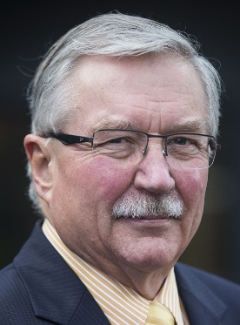

* A graduate of Auckland and Waikato Universities holding LLB, MJur, and PhD degrees
* A lawyer in practice in Auckland and Hamilton for 18 years
* Appointed a District Court Judge in 1989
* Lecturer in Law and IT 2000 – 2018
* Author of texts on Internet Law, Media Law, and the impact of new technologies on legal principles and legal culture
* Speaker at local and international conferences on Law and IT
* Retired from judicial duties in December 2021
* Mentor of junior lawyers at Public Defence Service 2022
* Barrister 2022 – present and door tenant at Sangro Chambers, Auckland
* Writes a fortnightly column for “The Listener” on Law and Society
* Writes regularly on legal, media, governance, literature and cultural issues at “A Halflings View” – <http://djhdcj.substack.com>

[](https://events.humanitix.com/nzisf-mar-2025/tickets)

[**https://events.humanitix.com/nzisf-mar-2025/tickets**](https://events.humanitix.com/nzisf-mar-2025/tickets)

**Details for registration:**

* Registration fee: $10.00.
* Registrations will be accepted until the morning of Wednesday, 12th of March.
* ZOOM login will be circulated to attendees on Wednesday, 12th of March.

To place your name on the NZISF mailing list, [click here](mailto:lech@auckland.ac.nz?subject=add%20name%20to%20NZISF%20mailing%20list)  
To remove your name from the NZISF mailing list, [click here](mailto:lech@auckland.ac.nz?subject=remove%20from%20NZISF%20mailing%20list)